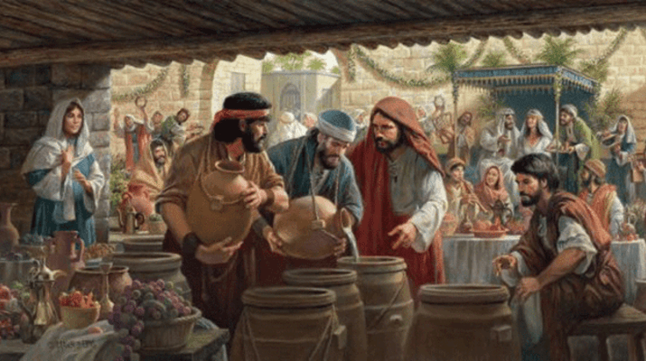
AS VODAS DE CANÁ

