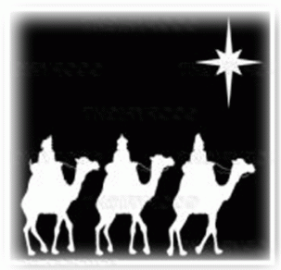[](http://1.bp.blogspot.com/-JMkUgAeLln8/Tvzvy7isVTI/AAAAAAAAEE8/hFv6nsmlOwc/s1600/viaje+navidad+color.jpg)****

6-enero-2019

Epifanía