25-marzo-2018

6º CORESMA-B

[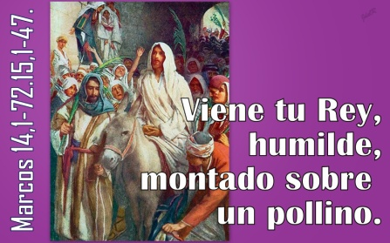](https://3.bp.blogspot.com/-3Jfb57TeeOQ/VRfi2lb2seI/AAAAAAAAJe8/VwujtzgW0Gg/s1600/33Marcos14,1-72.15,1-47Viene+tu+Rey.jpg)